The while loop is used to iterate a block of code repeatedly until the specified Boolean condition is true. As soon as the Boolean condition becomes false, the loop automatically stops. If the number of iteration is not fixed, it is recommended to use the while loop.

Syntax:

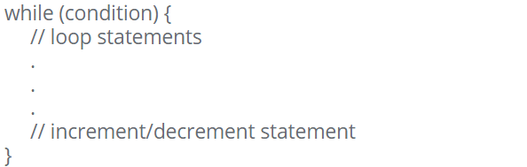

Block Diagram:

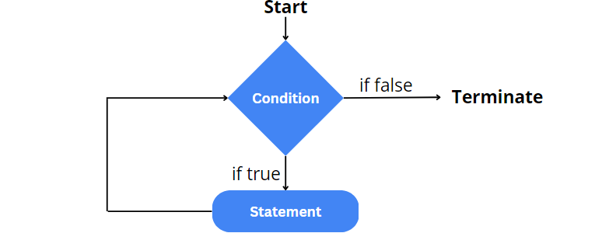

Example:

